Code Walkthrough

Dense Layer:

The first layer takes in random noise of shape (LATENT_DIM,) and processes it into a large 1D vector of neurons (in this case, 8*8*512). This noise vector is the "seed" for the generator to create a structured image.

Reshape Layer:

The vector is reshaped into a 3D structure of size (8, 8, 512), a small “image” format that grows larger in spatial dimensions through successive layers.

Transpose Convolution Layers:

These layers act like upsampling layers, increasing the height and width dimensions with each layer (from 8x8 to 16x16, then 32x32, and finally 64x64).Each transposed convolution (also known as "deconvolution") increases the image size by a factor of 2 while gradually reducing the number of filters (from 512 down to 64). The relu activation function adds non-linearity, enabling the model to capture complex patterns.

Batch Normalization is added after each layer, which helps stabilize and accelerate training by normalizing the inputs to each layer.

Final Convolution Layer:

This layer reduces the image depth to 3 channels (matching an RGB image) and uses tanh as the activation function. tanh is often used here because it outputs values between -1 and 1, which is useful for image data that is typically normalized to this range.

How the Generator Learns

During training, the generator outputs an image that’s evaluated by the discriminator model. If the discriminator correctly classifies it as “fake,” the generator receives feedback (loss) and adjusts its weights to improve its output. Over multiple iterations, the generator’s goal is to create images that the discriminator increasingly finds hard to distinguish from real images. This adversarial feedback loop between the generator and discriminator helps the generator learn to produce highly realistic images.

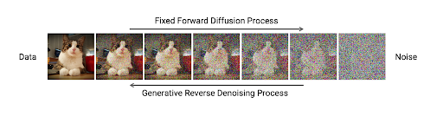

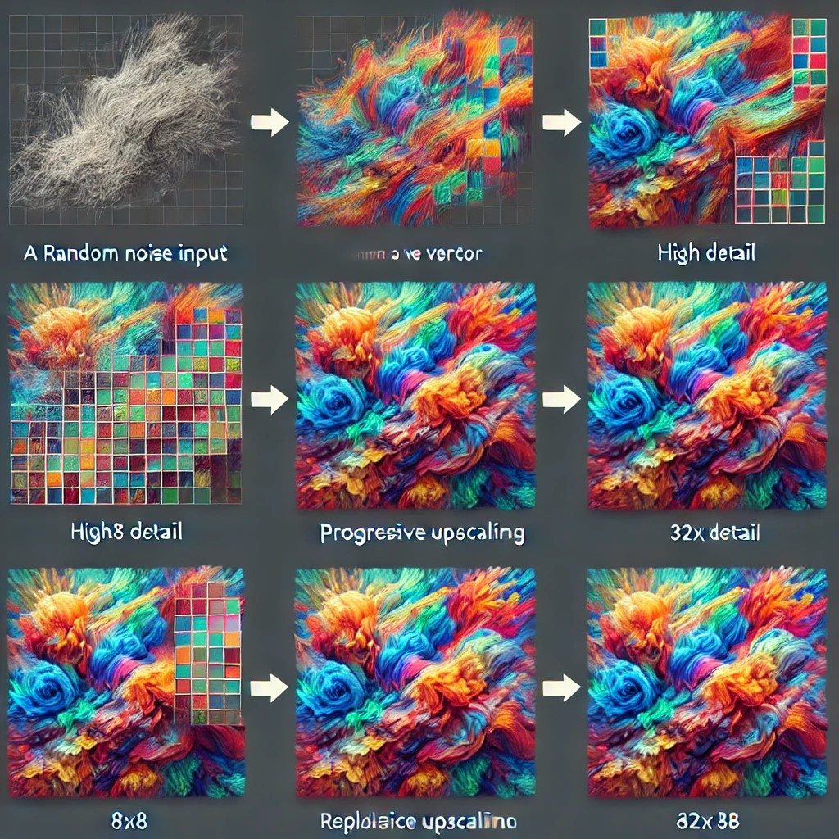

Dense Layer and Initial Reshape (8x8x512):

Description: The generator starts with random noise, which is turned into a dense (1D) vector and then reshaped to an 8x8 grid with 512 channels. This initial output is abstract, resembling a block of color or static noise without any recognizable features.

First Transposed Convolution (16x16):

Description: The model doubles the grid to 16x16, with fewer channels (256) but increased structure. Color starts emerging slightly, and blobs or faint patterns might appear, though details are still unclear.

Second Transposed Convolution (32x32):

Description: This layer scales the grid to 32x32, reducing channels to 128. Shapes become more defined; any background, foreground, or larger sections of the image begin to differentiate themselves, with clearer color patterns and basic structures forming.

Third Transposed Convolution (64x64):

Description: Now at full size (64x64), the image has even more refinement and detail. Specifics like edges, textures, and finer color gradients emerge, making the image start to resemble a realistic photo.

Final Layer (RGB):

Description: The generator produces a polished 64x64 RGB image. The 3-channel (RGB) output has final color corrections, contrast, and depth, giving it a completed look with sharp edges, colors, and textures.

**Code Breakdown**

1. **Generate Noise for the Generator**:

python

Copy code

noise = tf.random.normal([BATCH_SIZE, noise_dim])

This creates a batch of random noise vectors with shape [BATCH_SIZE, noise_dim]. This noise serves as the input for the generator to create a batch of fake images.

1. **Compute Generator and Discriminator Losses**:

python

Copy code

with tf.GradientTape() as gen_tape, tf.GradientTape() as disc_tape:

generated_images = generator(noise, training=True)

real_output = discriminator(images, training=True)

fake_output = discriminator(generated_images, training=True)

gen_loss = generator_loss(fake_output)

disc_loss = discriminator_loss(real_output, fake_output)

Using two tf.GradientTape contexts (gen_tape and disc_tape), this section:

* + **Generates fake images** by feeding the noise through the generator.
  + **Passes real and fake images to the discriminator** to obtain real_output (output of real images) and fake_output (output of generated images).
  + Calculates **loss for both the generator** (gen_loss) and **discriminator** (disc_loss). The generator's goal is to maximize fake_output (to fool the discriminator), while the discriminator's goal is to distinguish real images from fake ones.

1. **Calculate Gradients**:

python

Copy code

gradients_of_generator = gen_tape.gradient(gen_loss, generator.trainable_variables)

gradients_of_discriminator = disc_tape.gradient(disc_loss, discriminator.trainable_variables)

This step computes the gradients of gen_loss and disc_loss with respect to the generator and discriminator parameters, respectively.

1. **Apply Gradients to Update the Generator and Discriminator**:

python

Copy code

generator_optimizer.apply_gradients(zip(gradients_of_generator, generator.trainable_variables))

discriminator_optimizer.apply_gradients(zip(gradients_of_discriminator, discriminator.trainable_variables))

Finally, the computed gradients are applied to the generator and discriminator using their optimizers. This update step is where learning occurs: the generator becomes slightly better at creating realistic images, and the discriminator becomes slightly better at distinguishing real from fake images.

Generate Images from Noise:

python

Copy code

predictions = model(test_input, training=False)

predictions = (predictions + 1) / 2.0

test_input is a batch of noise vectors, usually the same set used each epoch to visualize the generator's progress.

model(test_input, training=False) passes this noise through the generator in inference mode (training=False) to produce a batch of generated images.

predictions = (predictions + 1) / 2.0 scales the pixel values from the [-1, 1] range to [0, 1], making them easier to display as standard RGB images.

Plot and Arrange Images in a Grid:

python

Copy code

fig = plt.figure(figsize=(4, 4))

A new figure is created with a 4x4 grid (16 slots) to hold the generated images.

The figsize determines the display size of the grid.

Loop to Display Each Generated Image:

python

Copy code

for i in range(predictions.shape[0]):

plt.subplot(4, 4, i+1)

plt.imshow(predictions[i])

plt.axis('off')

This loop iterates through the batch of generated images.

Each image is displayed in one of the grid’s 16 slots (4x4) using plt.subplot.

plt.axis('off') hides the axis labels for a cleaner visual.

Save the Image Grid to a File:

python

Copy code

plt.savefig('image_at_epoch_{:04d}.png'.format(epoch))

plt.close()

The generated grid is saved as a PNG file named with the current epoch number.

plt.close() closes the plot to avoid display issues if this function is called multiple times during training.